**Lecture #019**

**MARKOV PROCESS**

🡪 A random process in which the value – or *state* – of the process depends only on its immediate previous value – or state – and is independent of its values – or states – in the more distant past.

[Another statement: Future values of a Markov process are independent of its past values, given its present value.]

We will consider only discrete processes with discrete time steps.

We have already seen that the Poisson process is a Markov process.

Simple example:

A fair coin is being tossed repeatedly. Random process { Sum(n) } represents the number of heads observed in the first n tosses.

We can say Sum(n) = k=1..n Toss(k)

where Toss(k) = 1 if the kth toss yields head, and 0 otherwise.

Since the coin is fair, we can say that:

Prob[ Sum(n+1) = j+1 | Sum(n) = j ] = ½, and



Prob[ Sum(n+1) = j | Sum(n) = j ] = ½.

Note that the probabilities on the RHS depend only on Sum(n), and not on previous values of the process. In other words, only the total count of heads matters – not the way in which that count comes about.

Therefore { Sum(n) } is a Markov process.

A discrete Markov process with discrete time is also called a Markov chain, of which therefore the above is an example.

Let a Markov chain { X(n) } have **states** ... ai ... aj ... ak ... at various time instants; the state at time 0 is known as the initial state. In general, states ... ai ... aj ... ak ... will repeat in { X(n) }.

Let the set of all possible states of X(n) be A = { a1 , a2 ... am }. Exactly one of these is the initial state. The number of distinct states is m, which we shall assume to be finite, unless stated otherwise.

Then pij = Prob[ X(n) = aj | X(n-1) = ai } is called the *one-step transition probability* from state ai to state aj.

We will consider only the Markov chains in which the pij values are independent of time; these are called *homogeneous* Markov chains.

The matrix P = [ pij ] is called the *one-step transition probability matrix* (*TPM*) of the process. Clearly, this matrix is of size m x m.

In a TPM, note that:

(a) 0 < pij < 1, for all i,j and

(b) j pij = 1 for all values of i, which means that all row totals are 1.

**Why (a) and (b)?**

Note: Time instants are numbered 0, 1, 2 .... n ... (without bound), and the distinct process states are { a1 , a2 ... am }. We can say, for example, that X(1000) = a4 🡪 at time instant 1000, the process state is a4.

Definition: At a given time instant n, let the probability of the system being in state ak be denoted by pk, where k = 1, 2 ... m.

Let p(n)denote the row vector ( p(n)1 , p(n)2 ... p(n)m ) at time instant n. This is called the *probability distribution* of the process at time instant n.

Let p(0)denote the initial probability distribution ( p1(0) , p2(0) ... pm(0) ).

To specify a Markov chain completely, we must specify its one-step transition probability matrix **and** its initial probability distribution.

It can be shown fairly easily that p(n)= p(n-1)TPM = p(n-1)P.

In the form of a diagram, we have:

P

(TPM, m X m)

p(n) (1×m)

p(n-1) (1 x m)

Example:

A random process has states { 1, 2, 3, 4 }, which represent four points on the x-axis. At every time instant, the state of the process moves one step *to the right or to the left*, but it cannot move to the left of 1 or to the right of 4. The respective probabilities are as shown below.



[Note: For ease of understanding, there is a slight change in numbering here as compared to that used in the reference book.]



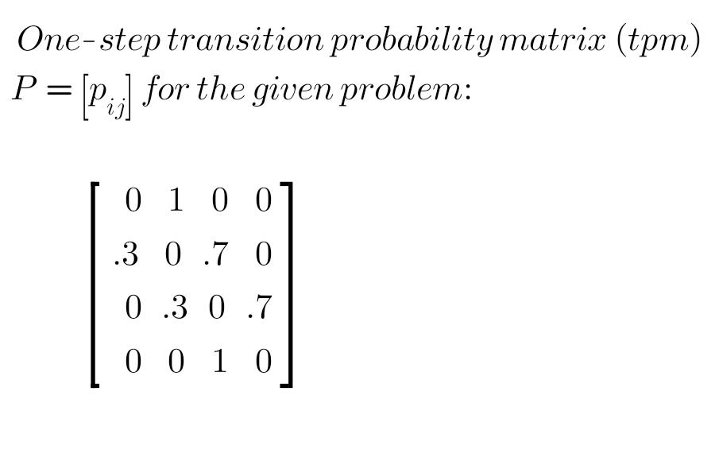[This process is called a “random walk with reflecting barriers"].

Let us take the initial distribution p(0) = ( ¼, ¼, ¼, ¼ ).

Then p(1) = p(0)P, p(2) = p(1)P .... and so on.

Prob[ X(1) = 3 | X(0) = 2 ] = P2,3 = 0.7 ... simply reading from P

Prob[ X(2)=2 , X(1)=3 | X(0)=2 ]

= Prob[ X(2)=2 | X(1)=3 ] * Prob[ X(1)=3 | X(0)=2 ]

= 0.3 * 0.7

= 0.21

Prob[ X(2)=2 , X(1)=3, X(0)=2 ]

= Prob[ X(2)=2 , X(1)=3 | X(0)=2 ] * Prob[ X(0)=2 ]



= 0.21*0.25

= 0.0525

Prob[ X(3)=4, X(2)=2 , X(1)=3, X(0)=2 ]

= Prob[ X(3)=4 | X(2)=2 , X(1)=3, X(0)=2 ] *

Prob[ X(2)=2 , X(1)=3, X(0)=2 ]

= Prob[ X(3)=4 | X(2)=2 ] * **// Markov property**

Prob[ X(2)=2 , X(1)=3, X(0)=2 ]

= 0

Note that the calculations for time instants 1, 2, 3 .... cannot be done in the absence of the initial probability distribution p(0), which serves as the starting point of the calculation.

However, at larger values of n, the probability distribution reached *may* *be* independent of p(0).

A state transition probability diagram can also be drawn.

“Random walk" Markov process is often used as a basis to model the behaviour of stock markets.